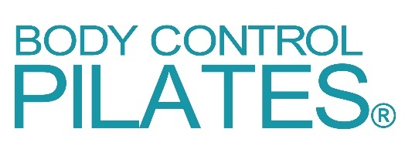

2021 Update
COVID-19 Supplementary Questionnaire
(Form CVSQ)

Completion of this form is required while government restrictions remain in place.
It is supplementary to the standard Body Control Pilates Enrolment Form.
This form only needs to be completed and submitted before your first visit after reopening.
Please complete this form, save it to your computer, and email it back to your teacher. Thank you.

IMPORTANT

If you have recently developed, or currently still have, any of the following symptoms please do not come to class. You should book a test as soon as possible and follow NHS advice to stay home until you receive the result. Please call 111 for further advice.
- a high temperature
- a new, continuous cough
- a loss or change to your sense of taste or smell

You can find more information here: Symptoms of coronavirus (COVID-19) - NHS (www.nhs.uk)

Your Name:

Current Address:
Email Address:
Mobile Phone Number:
Date of Birth:

You and COVID-19

 |  | YES | NO
1 | Have you had, or do you suspect you have had, Covid-19 Coronavirus?
2 | If yes, when?
3 | If yes, was this diagnosed by means of a positive test result?
4 | If yes, were you hospitalised?
5 | If you have had Covid-19, are you still experiencing symptoms?  If yes, please list them:
6 | If you answered ‘Yes’ to Question 4 and/or 5, do you know of any reason you should not exercise, or have you been advised not to partake in exercise by a medical practitioner?
7 | Does someone you live with or in your support bubble have symptoms or has recently tested positive for Covid-19?  If you answered ‘Yes’ to Question 7, please do not attend class while you isolate. More advice on isolation can be found at: When to self-isolate and what to do – Coronavirus (COVID-19) - NHS (www.nhs.uk)
8 | Are you allergic to specific cleaning products?  If yes, please give details:

Anything else?

9 | If there is anything else you would like us to know, please use this space:

YOUR SIGNATURE

I confirm that the above information is accurate to the best of my knowledge.

Signed:

Dated:

Thank you for providing the above information, which will be stored securely and used in complete confidence.

